Memory Management Exercise

Purpose: The purpose of this exercise is to practice memory management functions in Windows and Linux. For Mac PC owners, please explore to deliver your corresponding results accordingly.
Please provide your answer/inputs onto the space below “yellow” text area.

NOTES:
- Users of Different OS (e.g. Mac, or later versions of Windows OS): Please copy this document: Update/adjust the [instructions + screen captures] with your results. Your clever/better way of doing the tasks are welcome especially 😊.
- Lab Results Submission:
Please submit to your results online. If that fails, please email your results to: bangpanliang@gmail.com
The subject of the email should be: [Your StudentID, Assignment Name].

Windows

As we know from our reading, Windows uses virtual memory which is then mapped onto the actual physical memory in the computer as it is needed. This can, of course, get a little confusing. So first let’s look at how the physical memory is laid out on the typical i86 style computer or “PC”. Figure 1 shows a map of the physical layout of the memory.
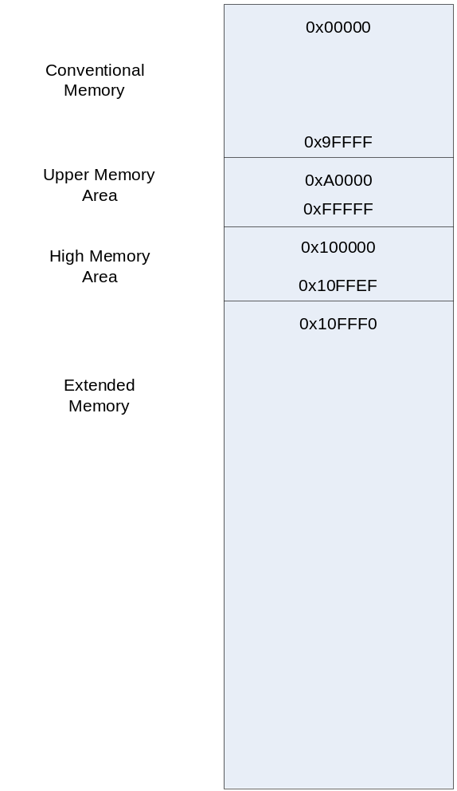The memory is divided into several areas. One of the more important is the Upper Memory Area. This area contains many of the critical components of a PC. For example, when a PC starts, the first thing it does is to load and execute the instruction in location 0xFFFF0. As the original i86 chips supported addresses up to 20 bits in length, this is the equivalent of every bit being set to ‘1’, except for the last 4.
The first instruction is stored in non-volatile memory, and is used to start the process of loading other instructions into regular memory. This is called “boot-strapping”. The non-volatile memory is called the BIOS – Basic Input Output System. This was used to not only configure the initial hardware, as it does now, but to also provide routines to the Operating System to manage I/O for the system. Because there is only a limited amount of space available to the BIOS, and I/O has become more varied and complex, the operating system itself now generally handles these functions.
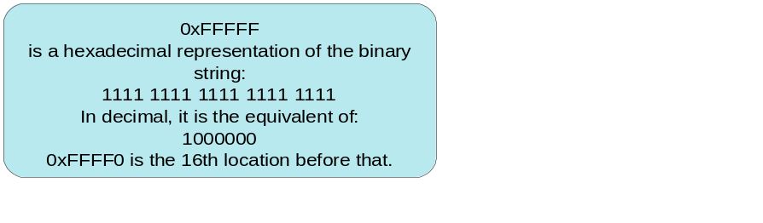Once the BIOS has completed its configuration, it checks to find a device with “bootable” code. The BIOS checks devices which have been included in their configuration. When it finds a device with the code “0xAA55” in the last two bytes of the first block of memory (sector for a hard drive), it will load that block (or boot sector) into memory location 0x7C00 and then point the Program Counter to that location, this causes the code from the boot sector to execute. That code can either be the start of an Operating System boot loader, or it can be a second level boot loader, such as “Grub”. The second level boot loader may present a choice to the user or different operating systems to load, or it may start a default Operating System. In all cases, once the Operating System boot code is begun, it starts loading itself into memory and setting itself up for use.
You can check to see what boot devices your computer supports by looking at the BIOS configuration screen. This is a simple interface that is loaded in the BIOS. Because it is not part of the main operating system you generally cannot get access to the BIOS during normal operations. Usually, there is an option during the start-up process that causes the BIOS interface to load rather than the Operating System. Often this is hitting the “delete” key, or “F7” key as the computer boots.
Once Windows is up and running, it will take over management of the physical memory, but it still needs to work with the processor to do so. For the most part, Windows will control the Conventional Memory range and the Extended Memory Range. Windows starts by dividing up the entire memory space into 64k chunks, or blocks. The areas that Windows will not actively manage are marked to avoid. Windows will also avoid some areas that are used for Direct Memory Mapping for I/O devices. In addition, Windows will reserve some blocks for itself to use for its core processes that it wants to always have in memory.
Now let’s look to see how much physical RAM we have on our system. To do this, open a “cmd” terminal, and enter the command “msinfo32”, an example is shown below. Please enter your results here:
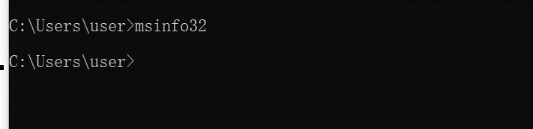
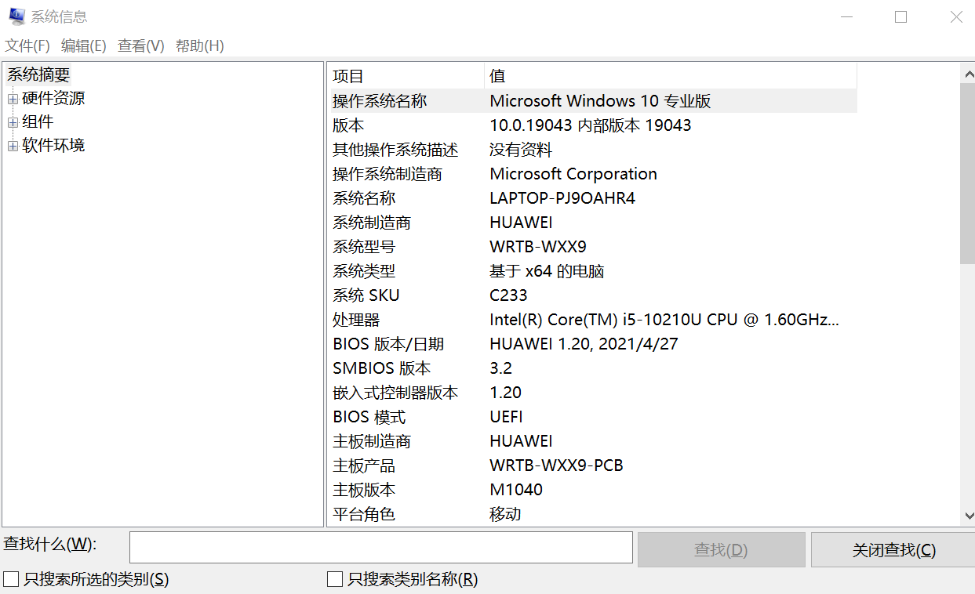
Another way to get system information is via the “systeminfo” command. An example is shown below. Please enter your results here:
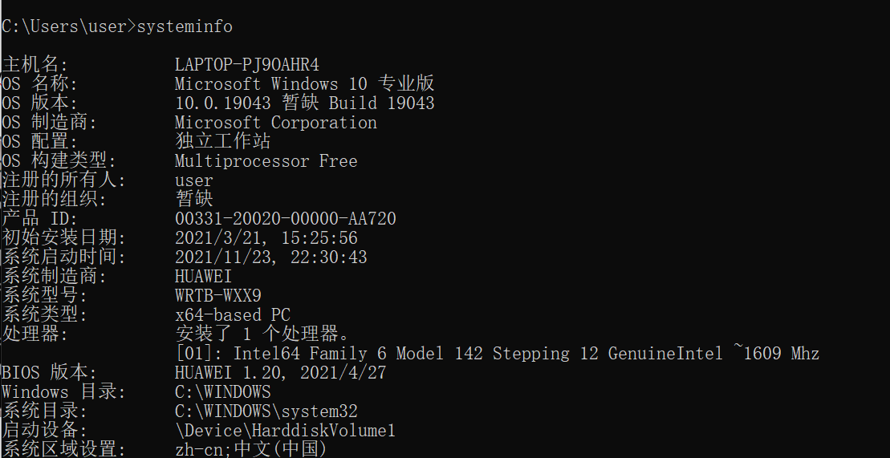

Please elaborate the major difference on the two outputs above on the space below.
Msinfo32 display system information of graphical interface.
Systeminfo displays the configuration information of some operating systems of this machine in the terminal.
Next start the “Task Manager” (remember: “ctrl-alt-delete”), then look at the “Performance” tab. An example is shown below. Please enter your results here:
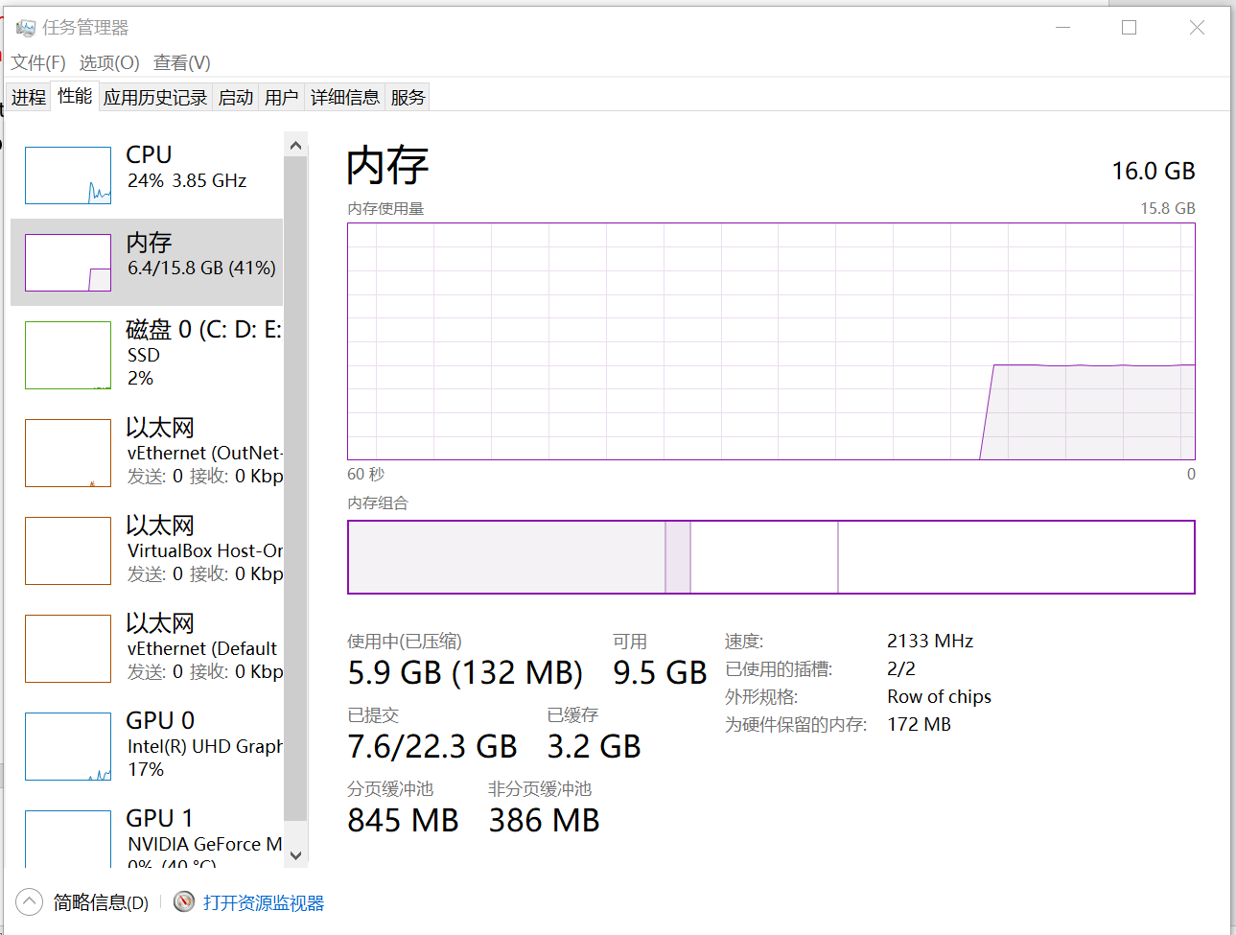
Next let’s look at a typical user program. From our reading, we know that Windows gives each process a theoretical 4GB address space. This space will be chopped up into 4K chunks, just like the physical memory. These chunks are called pages. The processes will only actually be allocated as much of that space as they need to hold their code, or which they request from the operating system for storage.
Return to the “System Information” terminal (per “msinfo32” command), in the “Virtual Memory” block you will see a number which gives the total amount of virtual file space on your system. An example is shown below. Please enter your results here:
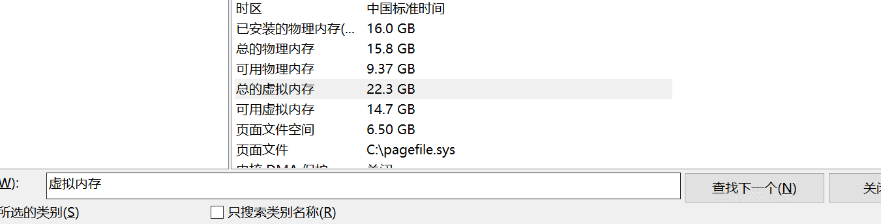

Now let’s go to the Window’s “Resource Monitor” App, and look at the other information about our memory.
An example is shown below. Please enter your results here:
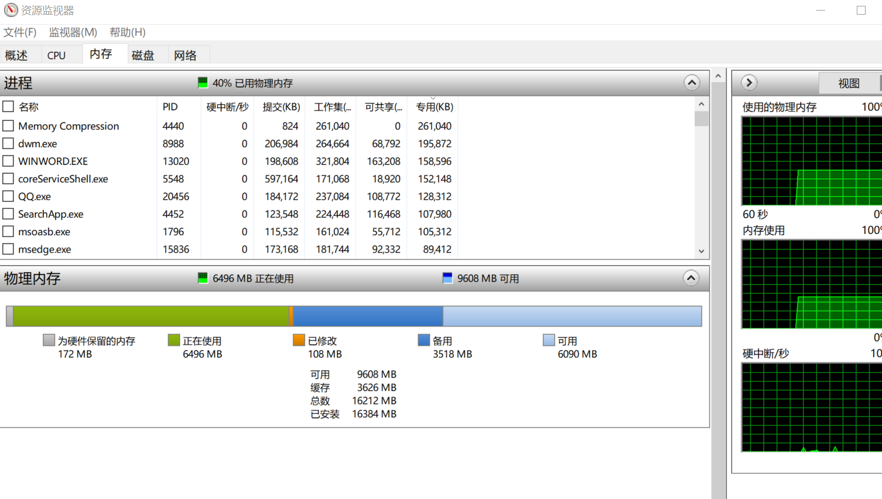

Let’s go look at the memory usage of a particular process. (e.g. “Snipping Tool”. Please launch this App in your PC).
Using the Windows Task Manager, click on the “Details” tab. Locate the process of your interest (an example is shown below). Take note of its PID!
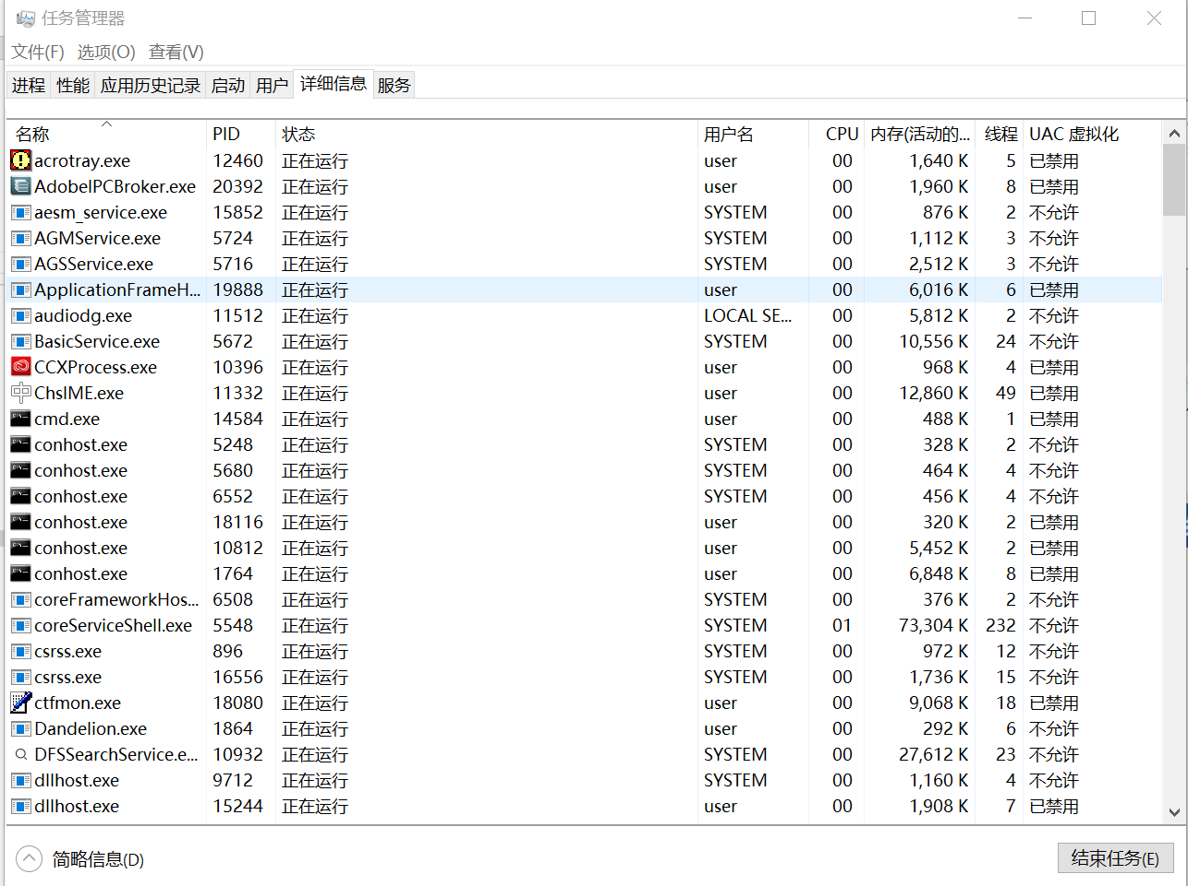

To monitor a particular process, open your “Resource Monitor”, sort the processes being displayed by its PID, and locate your process/App. An example is shown below.

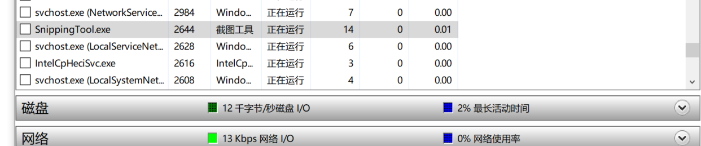
Select to monitor this process. An example is shown below.
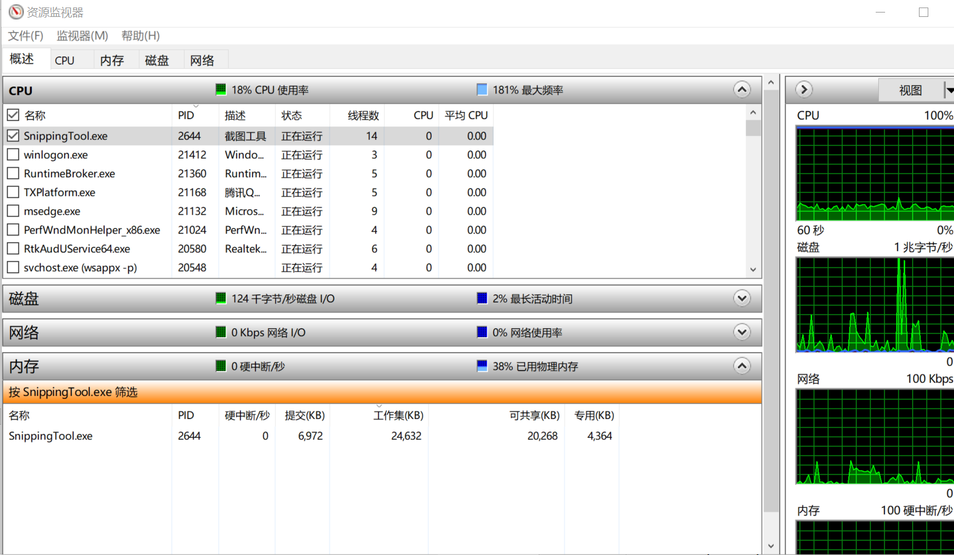
Open a copy of “Notepad” and find “notepad.exe” in the “Windows Task Manager”. Duplicate the steps above showing the “notepad.exe” results below.
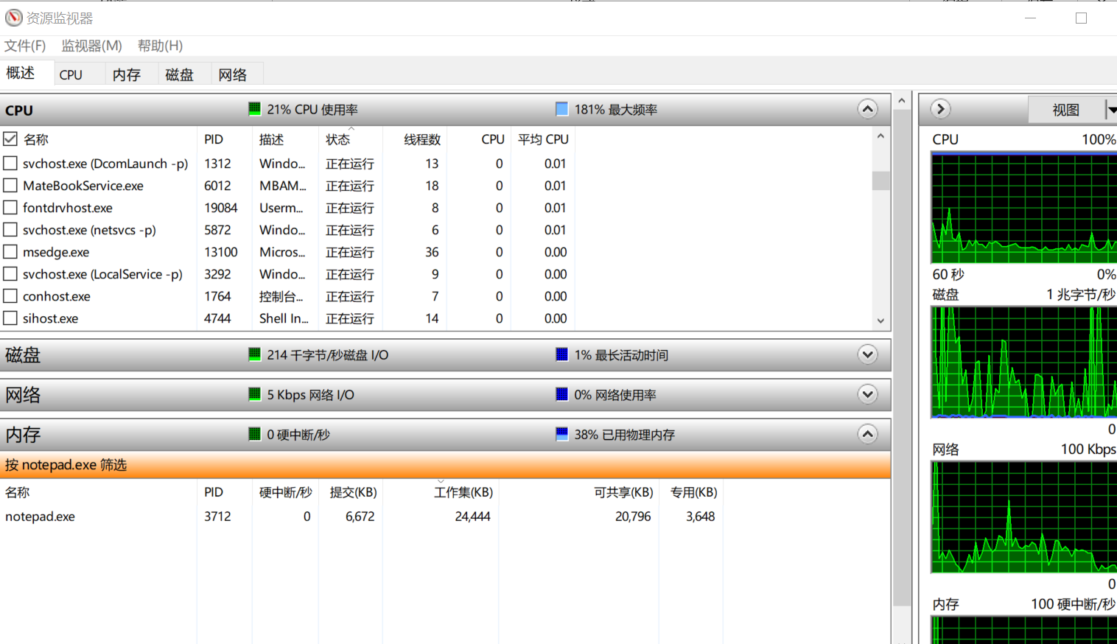
Microsoft has another tool available that lets us take a more detailed look at information about the memory usage. The tool is “vmmap” and is available for download at:
http://technet.microsoft.com/en-us/sysinternals/dd535533.aspx
Feel free to download this and explore further.
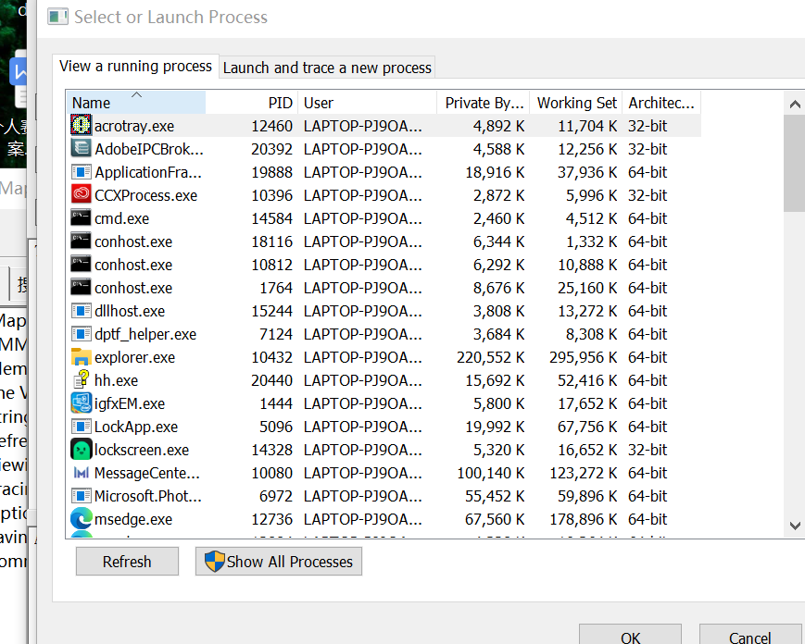

Linux

Linux on an Intel Architecture based computer is started in just the same way as Windows is. The boot loader puts the boot sector or block into memory, sets the program counter to that location, and the operating system then begins to load itself.
As with Windows, the first thing we want to check is how much memory we have on our system. The quickest and most straight forward way to do this is to look at the “/proc/meminfo” file. The command is :
cat /proc/meminfo
Run the command and put the results in the space below. Your results should look similar to this:
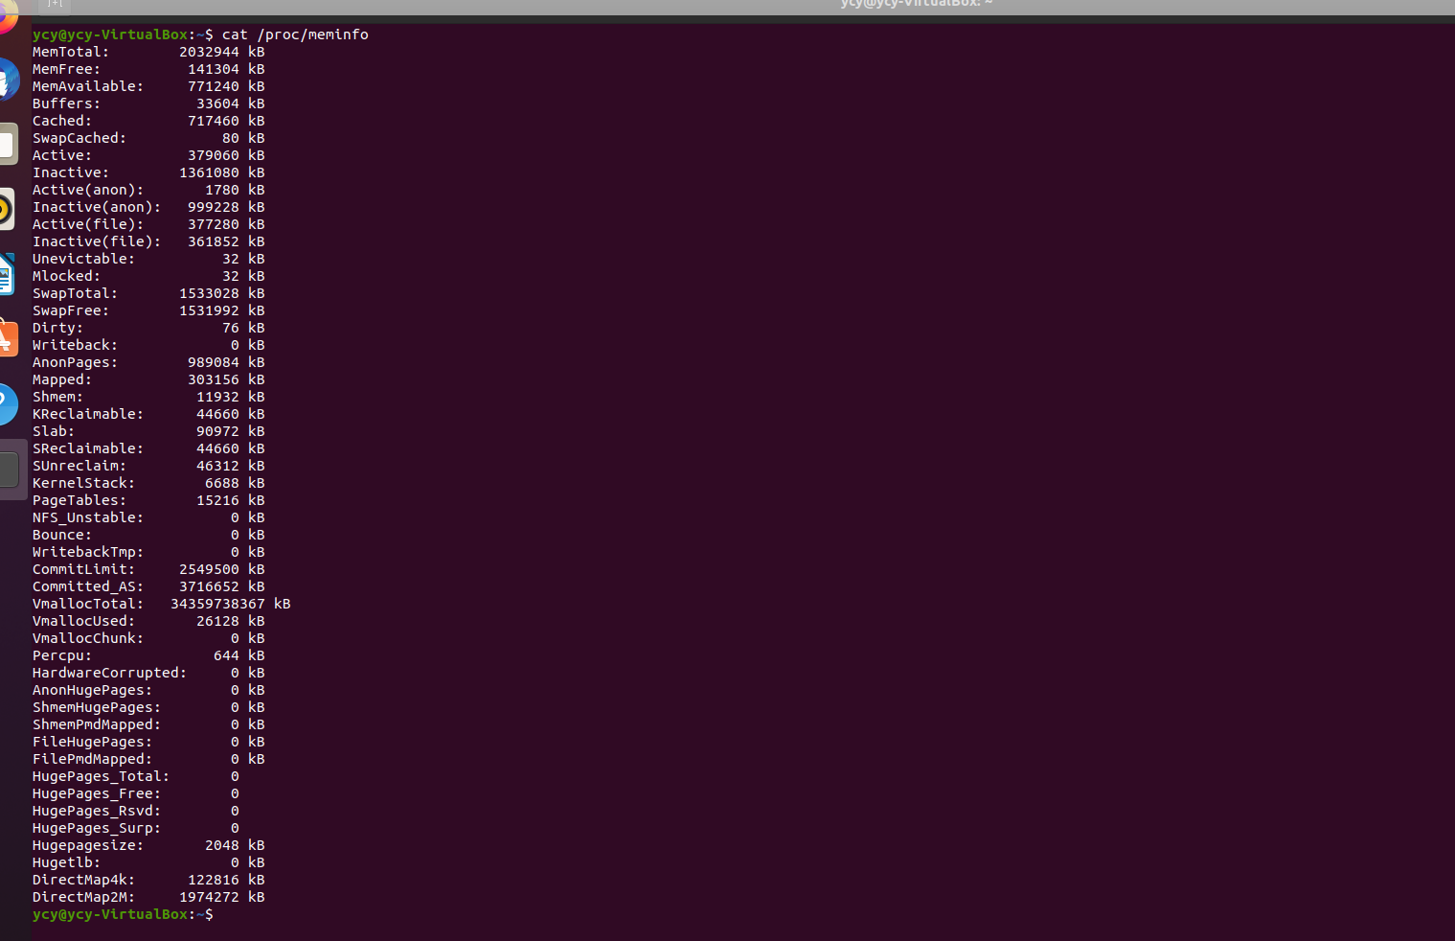
The first number we encounter is 129687552, which is the amount of physical memory minus those pieces of memory which are trimmed out because of the conflicts in the upper memory area, and that are used by the part of the Linux Kernel which needs to stay always stay resident in physical memory.
The next two numbers show the Used and Free physical memory.
Another method to look at the memory on a Linux System can be found on this link: https://www.binarytides.com/linux-command-check-memory-usage/
Please practice at least two of the commands and capture your results below. (Note: In case you Linux installation do not support some of the commands, I recommend to practice it from this website: https://bellard.org/jslinux/vm.html?url=https://bellard.org/jslinux/buildroot-x86.cfg)
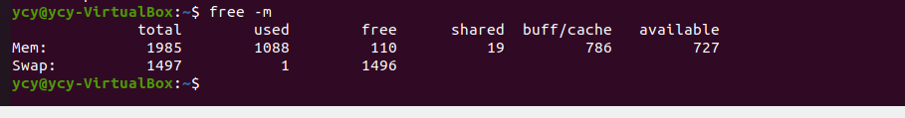
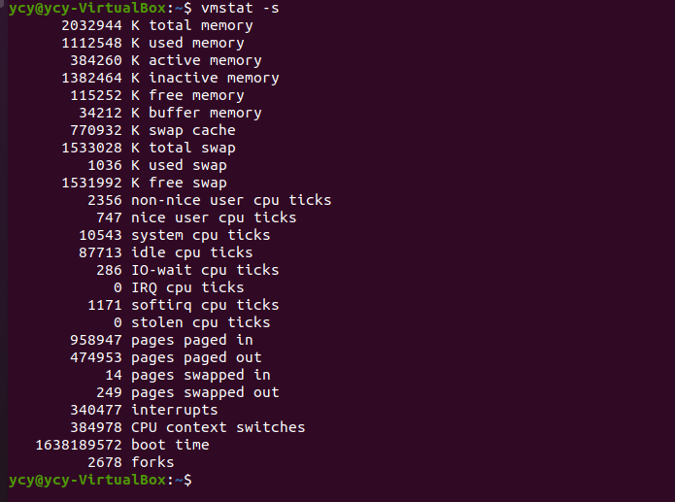
Linux, like Windows, has 4 GB user spaces for each process. Unlike Windows, Linux by default allocates 3 GB to the user process and only 1 GB to the kernel (Windows splits 2G and 2G). The following figure gives a really good explanation of how that space is used for each process.
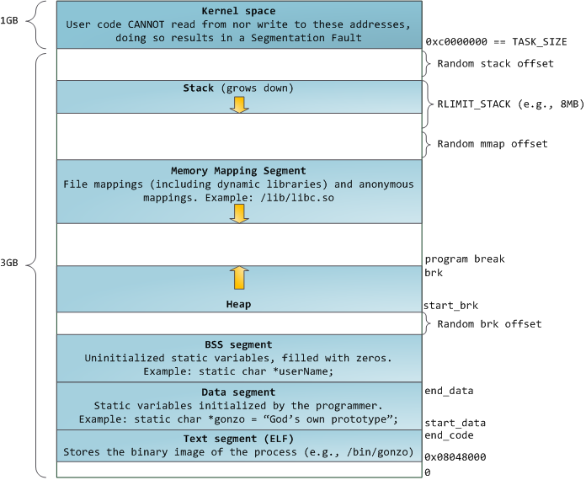
Source: http://duartes.org/gustavo/blog/post/anatomy-of-a-program-in-memory, Feb 2011.

While each process will have its own memory space, only the amount of that space actually used will be allocated space in virtual memory. The quickest and most common place to see how much virtual memory is allocated is with the “ps” command. In addition to the PID, it will give us the number of pages of virtual memory allocated to the process. On an Intel based machine, this will be in 4K pages.
As a process runs, it will designate new memory requirements, perhaps through a “malloc()” call. This will result in Linux allocating more pages of virtual memory to the process. These pages will be activated in the process memory space. Once the process tries to actually write to those additional pages, there will be a “page fault” and Linux will map those pages to physical memory.
Note: The “free” command will also give a good display of the memory usage in the system.
This process memory is going to be mapped into physical memory in a way which is similar, but still different from Windows. First, the lowest 1GB (or 1/4th whichever is smaller, if it is above a minimum) of the physical memory is reserved for kernel memory. This means that in general, kernel and user pages from virtual memory will not use the same frames in physical memory.
If Linux needs to bring a page into physical memory, and there are no frames available, then the operating system will move a page (or set of pages) into swap space (if it has a “swap” partition) to make room for the new pages. Unlike Windows, most of the time Linux doesn’t use a swap file, but rather uses one or more (up to 64) swap partitions on a hard drive.
Now let’s see where the Virtual Memory for this process is mapped in physical memory. Use the command:
more /proc/PID_NUMBER_HERE/maps
Be sure to replace the PID_NUMBER_HERE with the PID found using “ps”. Place the results on the space below. Provide an explanation of each of the fields
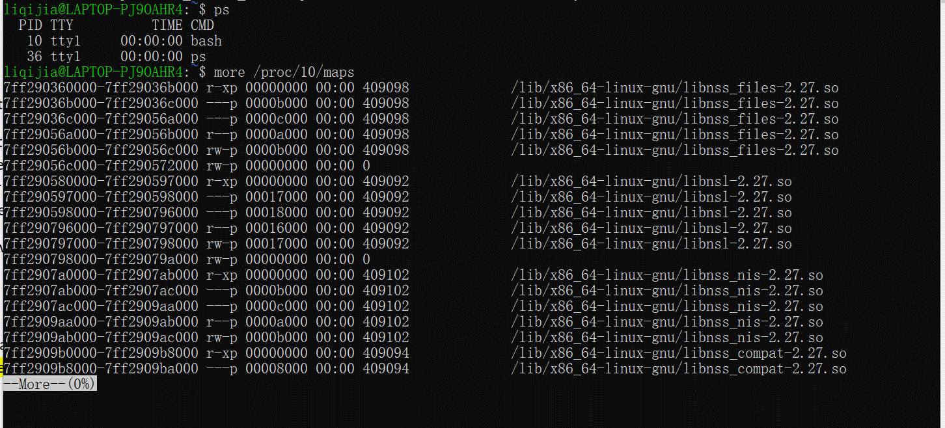
Discuss, on the space below, the changes you could make to programs to address specific memory management issues found as a result of using these command/tools. [e.g. examine usage and efficiency of “malloc”; Pay close attention return memory to OS with “free()”; Avoid allocating/referencing specific memory locations, let the OS assign the address. ….]

When the program is actually running, the system will first map the virtual address to the range in the physical address. Another concept: virtual memory. Virtual memory is a contiguous address space in memory. The meaning of physical storage location does not necessarily refer to physical memory, but may also be an address space opened up on the hard disk. So I can use some “-s、-m” to locate it.

